Data summary for the Mindful Healthcare Scale

Scoring:

Engaged subscale: Reverse score items 3, 4, and 13 and add them to items 1 and 7.
(Higher scores = greater engagement)

Awareness subscale: Reverse score items 5 and 10 and add them to items 6, 8, and 12
(Higher scores = greater awareness)

Defusion subscale: Reverse score and sum items 2, 9, 11
(Higher scores = less fusion / greater defusion)

Total score = sum all items, after doing the reversals described above

Reliability
Cronbach’s coefficient alphas for the MHS subscales were .74 (‘engaged’), .71 (‘awareness’), and .74 (‘defusion’), indicating acceptable internal consistency. The full scale had an alpha of .79, which was also acceptable.

Factor structure
Confirmatory factor analysis results for sample 2 (n = 196)
Model | χ² | df | p value | NC | CFI | IFI | RMSEA | SRMR
 | 71.962 | 59 | .12 | 1.220 | .980 | .980 | .033 | .046

Path Diagram of the final version of the MHS, including factor loading for each item
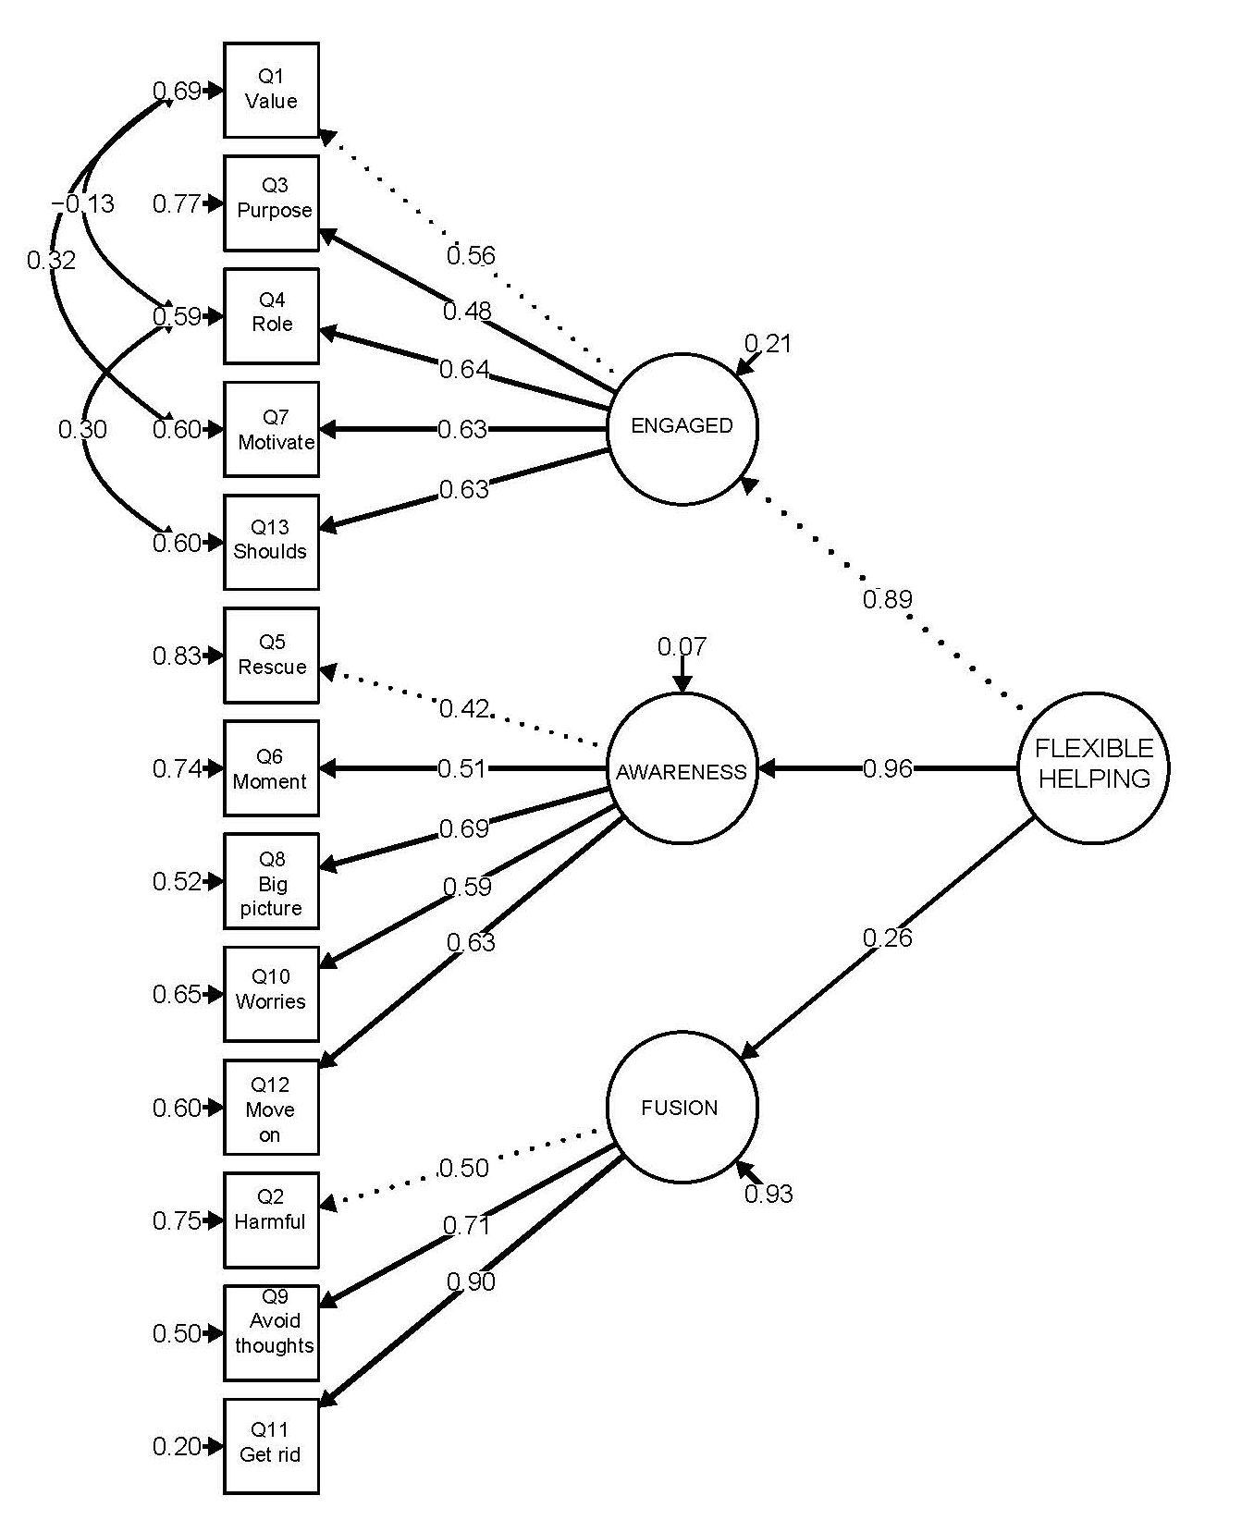

Convergent validity
Correlations between MHS and other constructs in sample 2 (n = 196)
Measure | Correlation (r) with the MHS
 | Total Scale | Engaged  Subscale | Awareness  Subscale | Defusion  Subscale
Comprehensive Assessment of ACT Processes (CompACT)  Overall Flexible Helping (Full Scale)  Openness to Experience Subscale  Behavioural Awareness Subscale  Valued Action Subscale | .68**  .62**  .54**  .54** | .57**  .45**  .47**  .54** | .59**  .51**  .53**  .45** | .32**  .41**  .17**  .16*
Interpersonal Reactivity Index (IRI)  Perspective Taking Subscale  Empathic Concern Subscale  Fantasy Subscale  Personal Distress | .16*  .06  -.10  -52** | .14*  .20**  -.06  -.38** | .10  -.06  -.24  -.53** | .10  -.01  .08  -.23**
Self-Compassions Scale - Short Form (SCS-SF) | .58** | .43** | .53** | .30**
Oldenburg Burnout Inventory (OBI)  Total Scale  Exhaustion Subscale  Disengagement Subscale | -.62**  -.57**  -.54** | -.66**  -.56**  -.65** | -.50**  -.47**  -.40** | -.15*  -.17**  -.81**
*Correlation is significant at the 0.05 level (1-tailed) ** Correlation is significant at the 0.01 level (1-tailed)

The MHS is free to use for non-commercial purposes, it is still in development so if you are doing research with it we would appreciate collaborating with you to share data and contribute to the validation paper. Please contact David Gillanders, University of Edinburgh to do so. david.gillanders@ed.ac.uk

Mindful Healthcare Scale

This questionnaire asks about your experiences as a helping professional. It asks about thoughts, feelings, perspectives, things you care about and things you find hard in your work with people.

Throughout, we use the term ‘client’ to describe people who receive your services, but you may prefer to use a different term such as ‘patient’ or ‘service user’.

Please rate how true each statement is for you. Generally, your first response or gut reaction is important, so try not to spend too long thinking about each statement.

1 | 2 | 3 | 4 | 5 |  |  | 6
never  true | very  seldom true | sometimes  true | frequently  true | almost always true |  |  | always  true
- I know what I value in my work with clients. |  |  |  |  | 1 | 2 |  | 3 | 4 | 5 | 6
- It is harmful to have negative thoughts about a client. |  |  |  |  | 1 | 2 |  | 3 | 4 | 5 | 6
- I feel little sense of purpose in my job. |  |  |  |  | 1 | 2 |  | 3 | 4 | 5 | 6
- I don't get much from my role as a helping professional. |  |  |  |  | 1 | 2 |  | 3 | 4 | 5 | 6
- I get caught up in trying to "rescue" or being overprotective of my clients. |  |  |  |  | 1 | 2 |  | 3 | 4 | 5 | 6
- When working with clients, I pay attention to what is occurring in the moment between us. |  |  |  |  | 1 | 2 |  | 3 | 4 | 5 | 6
- I know what motivates me in my work with clients. |  |  |  |  | 1 | 2 |  | 3 | 4 | 5 | 6
- If I have a bad day at work, I can step back and see the bigger picture. |  |  |  |  | 1 | 2 |  | 3 | 4 | 5 | 6
- I try hard to avoid negative thoughts about my therapeutic work. |  |  |  |  | 1 | 2 |  | 3 | 4 | 5 | 6
- Worries about my abilities as a helping professional get in the way of my work. |  |  |  |  | 1 | 2 |  | 3 | 4 | 5 | 6
- If an unpleasant thought about a client comes into my head, I try to get rid of it. |  |  |  |  | 1 | 2 |  | 3 | 4 | 5 | 6
- I am able to move on from negative thoughts about my therapeutic work. |  |  |  |  | 1 | 2 |  | 3 | 4 | 5 | 6
- My job feels like something I "should" do, rather than something I "want" to do. |  |  |  |  | 1 | 2 |  | 3 | 4 | 5 | 6

Thank you for completing this questionnaire

